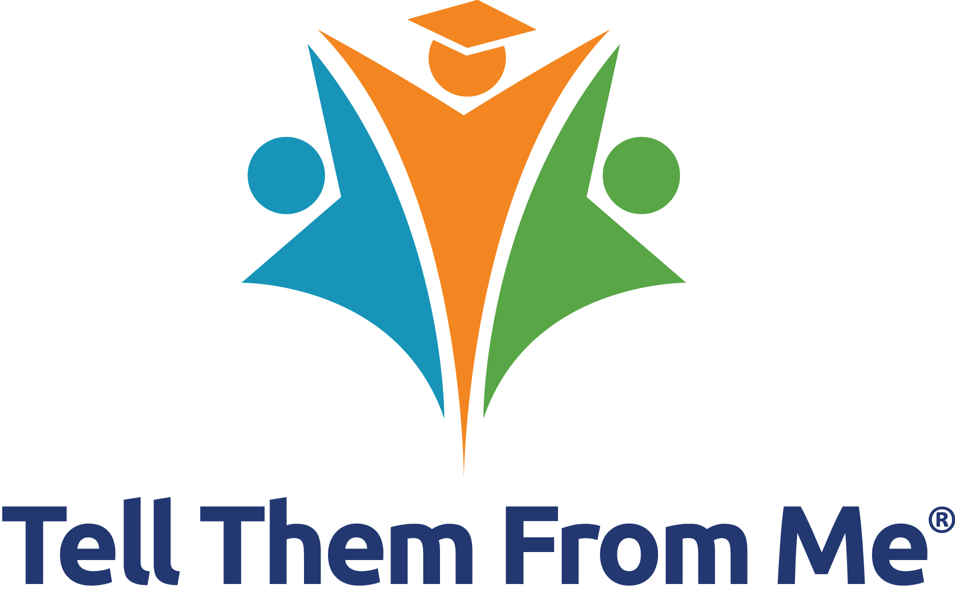Student Voice Action Plan:

How are we currently incorporating student voice, and how

can we improve?

|  |  |
| --- | --- |
| Intended Audience  School Staff | Intended Use  The *TTFM* Student Survey provides schools with the ability to capture the authentic voices of their students, allowing you to make a meaningful impact in all areas of school growth. Research demonstrates that students who are given a forum to express their voice are more likely to be academically engaged with school. Student perception surveys also have the power to impact teaching and learning in the classroom.  Use this worksheet with your staff to record how you are currently using student voice, ideas for improving, and to draft an action plan to incorporate ideas from your team. Feel free to use chart paper or a white board when brainstorming with your teams! |
|  |  |



|  |  |
| --- | --- |
| **Step 1:** How are we currently incorporating student voice? | **Step 2:** How can we adjust our current approach? |
| *Example:*   * *We review the TTFM One-Click Report results during our staff meeting.* * *We share some results with parents and families in our school newsletter.* * *We do not share results with students, although in the past we have discussed ways we could do this.* | *Example:*   * *We could share results with parents and families throughout the year.* * *We can share results with students.* * *We could hold focus groups with students to gather more information about the results, and their ideas for improvements.* * *We could also have students look at the results and make predictions.* * *We could incorporate our results into our school improvement planning.* |
|  |  |

|  |  |  |  |  |
| --- | --- | --- | --- | --- |
| **Step 3:** Brainstorming | | **Step 4:** Next Steps | | |
| What will we change *this year*? | Initial ideas to achieve success | Planning Team | | When will we hold the first planning team meeting? |
| Who will lead the team? | Other team members |
| *Example:*   * *We will hold focus groups with students to gather more information about the results, and their ideas for improvements.* | * *We can hold sessions with specific sub-groups of students (for example, grade 6’s, female only, etc.)* * *We can show survey results to students to spur conversation.* * *Ideas and comments can be recorded on chart paper.* * *We will need to be sure to let students know that we may be making changes based on their comments, and that we will share the plans for change.* * *The focus groups need to be seen as an open and safe space for conversation so students feel comfortable sharing their ideas.* | *TBC* | *TBC* | *Semester 1 Date* |
| *Example:*   * *We will share results with parents and families throughout the year, rather than only in Term 4.* | * *We can share results with parents each month using our newsletter. We can also share results once per month using social media and on our bulletin board near the office.* * *We can create a student-led team that shares the results and ideas for improvements with parents and families.* * *We can hold a session with parents and families to review the results, but also to collect their comments and ideas for improvements.* | *TBC* | *TBC* | *Semester 1 Date* |
|  |  |  |  |  |
|  |  |  |  |  |